LAB Assignment No 7
Interfacing DHT22 Sensor with ESP32 and Visualizing Temperature & Humidity on Node-RED Dashboard
Lab Description:
This lab demonstrates real-time environmental monitoring using IoT, where sensor data is transmitted via MQTT and visualized using a web dashboard.
Learning Objectives:
By the end of this lab, students will:
- Interface digital sensors (DHT22) with ESP32
- Publish real-time data using MQTT
- Visualize IoT data using Node-RED
- Build dashboards with charts and gauges
- Simulate IoT systems using Wokwi
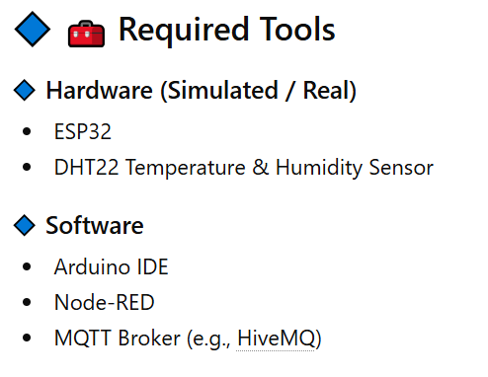
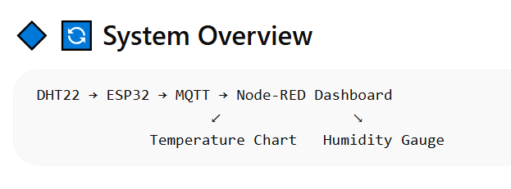
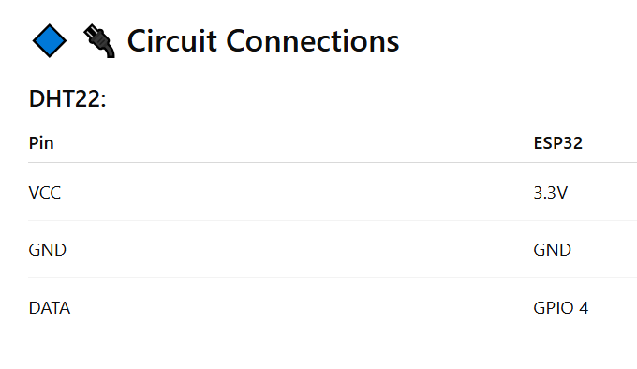
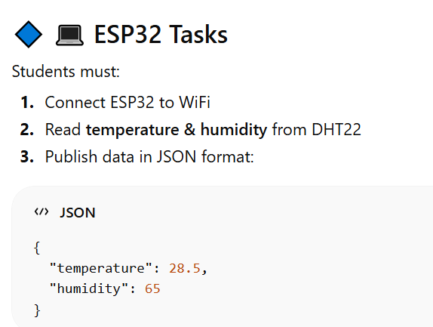

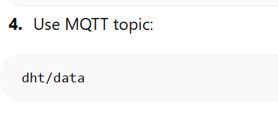
ESP32 Code:
#include <WiFi.h>
#include <PubSubClient.h>
#include "DHTesp.h"

const int DHT_PIN = 9;

DHTesp dhtSensor;

const char* ssid = "Wokwi-GUEST";
const char* password = "";
const char* mqtt_server = "broker.hivemq.com";

WiFiClient espClient;
PubSubClient client(espClient);
unsigned long lastMsg = 0;
#define MSG_BUFFER_SIZE (50)
float temp = 0;
float hum = 0;
int value = 0;

void setup_wifi() {

delay(10);
// We start by connecting to a WiFi network
Serial.println();
Serial.print("Connecting to ");
Serial.println(ssid);

WiFi.mode(WIFI_STA);
WiFi.begin(ssid, password);

while (WiFi.status() != WL_CONNECTED) {
delay(500);
Serial.print(".");
}

randomSeed(micros());

Serial.println("");
Serial.println("WiFi connected");
Serial.println("IP address: ");
Serial.println(WiFi.localIP());
}

void callback(char* topic, byte* payload, unsigned int length) {
Serial.print("Message arrived [");
Serial.print(topic);
Serial.print("] ");
for (int i = 0; i < length; i++) {
Serial.print((char)payload[i]);
}
Serial.println();

// Switch on the LED if an 1 was received as first character
if ((char)payload[0] == '1') {
digitalWrite(2, LOW); // Turn the LED on (Note that LOW is the voltage level
// but actually the LED is on; this is because
// it is active low on the ESP-01)
} else {
digitalWrite(2, HIGH); // Turn the LED off by making the voltage HIGH
}

}

void reconnect() {
// Loop until we're reconnected
while (!client.connected()) {
Serial.print("Attempting MQTT connection...");
// Create a random client ID
String clientId = "ESP8266Client-";
clientId += String(random(0xffff), HEX);
// Attempt to connect
if (client.connect(clientId.c_str())) {
Serial.println("Connected");
// Once connected, publish an announcement...
client.publish("IoT/mqtt", "IoT");
// ... and resubscribe
client.subscribe("IoT/mqtt");
} else {
Serial.print("failed, rc=");
Serial.print(client.state());
Serial.println(" try again in 5 seconds");
// Wait 5 seconds before retrying
delay(5000);
}
}
}

void setup() {
pinMode(2, OUTPUT); // Initialize the BUILTIN_LED pin as an output
Serial.begin(115200);
setup_wifi();
client.setServer(mqtt_server, 1883);
client.setCallback(callback);
dhtSensor.setup(DHT_PIN, DHTesp::DHT22);
}

void loop() {

if (!client.connected()) {
reconnect();
}
client.loop();

unsigned long now = millis();
if (now - lastMsg > 2000) {
lastMsg = now;
TempAndHumidity data = dhtSensor.getTempAndHumidity();

String temp = String(data.temperature, 2);
Serial.print("Temperature: ");
Serial.println(temp);
client.publish("IoT/temperature", temp.c_str());

String hum = String(data.humidity, 1);
Serial.print("Humidity: ");
Serial.println(hum);
client.publish("IoT/humidity", hum.c_str());
}
}

